Abstract
XXX.

Keywords: XXX

Περίληψη
ΧΧΧ.

Λέξεις κλειδιά: ΧΧΧ

Introduction / Εισαγωγή

XXX.

Method / Μεθοδολογία

Participants / Συμμετέχοντες
ΧΧΧ.

Instruments / Όργανα μέτρησης
ΧΧΧ.

Procedure / Διαδικασία
ΧΧΧ.

Results / Αποτελέσματα

Subheading / Υπο-ενότητα
ΧΧΧ.

Πίνακες και Διαγράμματα

Example / Παράδειγμα
Table ΧΧ. Descriptive statistics for the pre-competition variables for the two groups.
 | Experimental group |  |  |  | Control group
 | Competition 1 |  | Competition 2 |  | Competition 1 |  | Competition 2
 | M | SD | M | SD | M | SD | M | SD
Competition importance | 5.67 | 1.90 | 5.88 | 1.51 | 6.50 | 1.73 | 5.75 | 1.27
Cognitive anxiety | 1.46 | 0.60 | 1.18 | 0.43 | 1.08 | 0.57 | 1.26 | 0.39
Somatic anxiety | 1.02 | 0.62 | 0.77 | 0.52 | 0.85 | 0.66 | 0.70 | 0.54
Self-confidence | 1.56 | 0.56 | 1.46 | 0.57 | 1.65 | 0.47 | 1.86 | 0.64

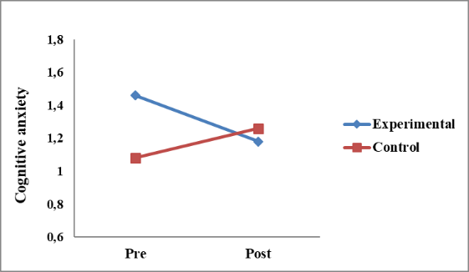 | 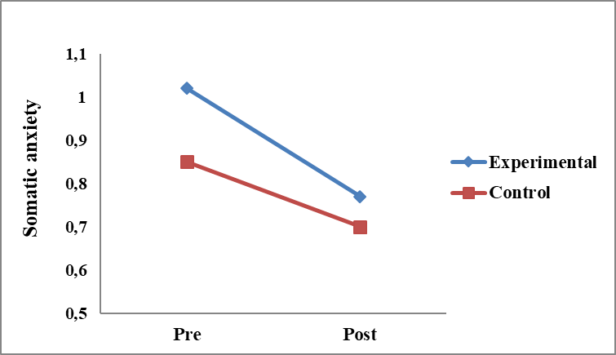
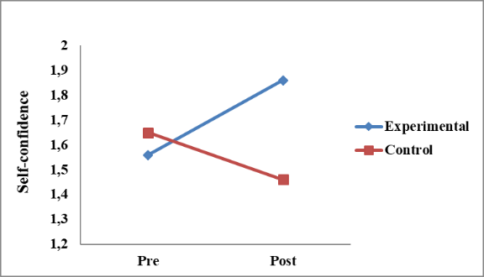
Figure XX. Changes in anxiety and confidence for the two groups across competitions.

Discussion / Συζήτηση

XXX.

Significance for Sport or/and Physical Education or/and Quality of Life
Σημασία για τον Αθλητισμό ή/και τη Φυσική Αγωγή ή/και την Ποιότητα Ζωής
ΧΧΧ.

References / Βιβλιογραφία

Example / Παράδειγμα

Research article / Ερευνητικό άρθρο
Hatzigeorgiadis, A., Zourbanos, N., Galanis, E., & Theodorakis, Y. (2011). Self-talk and sports performance: A meta-analysis. Perspectives on Psychological Science, 6(4), 348-356. https://doi.org/10.1177/1745691611413136

Book chapter / Κεφάλαιο σε βιβλίο
Galanis, E., Hatzigeorgiadis, A., Zourbanos, N., & Theodorakis, Y. (2016). Why self-talk is effective? Perspectives on self-talk mechanisms in sport. In M. Raab, P. Wylleman, R. Seiler, A.-M. Elbe, & A. Hatzigeorgiadis (Eds.), Sport and exercise psychology research: From theory to practice (pp. 181–200). London: Academic Press Elsevier. doi:10.1016/B978-0-12-803634-1.00008-X

Book / Βιβλίο
Moran, A. (1996). The psychology of concentration in sport performers: A cognitive analysis. Hove, UK: Psychology Press.

